

Iqueue Project

Testing Document

Software Engineering for Automation (2022-2023)



Summary

1. White Box Testing 3

2. Black Box Testing 4

2.2 4

The following documentation helps to explain the different testing benchmark applied to the Iqueue software. For each of the most important components of the software, some test sets are developed in order to guarantee their robustness to possible wrong inputs from the users and to assure that the outputs of the system are anyway correct.

# White Box Testing

Metti cose appunti su cose white box-testing

# Black Box Testing

Metti cose appunti su cose black box-testing

# Test set: **Account Registration**

Software tested

**Iqueue – registration view**

Version

Latest

Goal

To show that the registration code is robust with respect to different inputs from the users.

* + 1. **Test Case 1: Birthday after the current date**

*Goal*

To show that the registration code will not allow to insert an invalid birthday

*Input*

Birthday: 0/7/2050

*Expected output*

“The birthday cannot be in the future”

*Actual output*

“The birthday cannot be in the future”

*Result*

The code is robust with respect to a user who tries to put a future birthday

* + 1. **Test Case 2: Wrong email**

*Goal*

To prove that the system will not allow to put an incorrect mail in the registration

*Input*

Email field: niccolo.veronese.it

*Expected output*

Impossible to create the account without a correct email field

*Actual output*

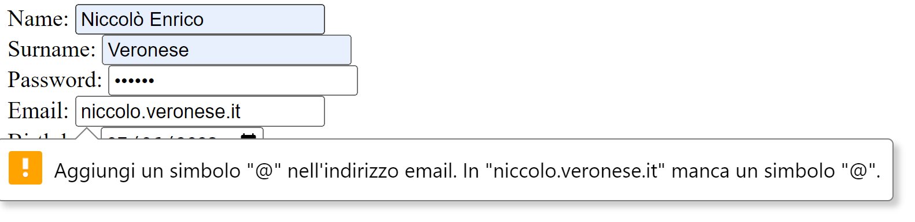

*Result*

The code shows good robustness with respect to wrong emails.

* + 1. **Case 3: Account with the same email address of another user**

*Goal*

To guarantee that two user do not have the same email address

*Input*

Email address: [gianluca99.giacomelli@gmail.com](mailto:gianluca99.giacomelli@gmail.com) (already existing)

*Expected output*

Validation error: "the given email is already registered"

*Actual output*

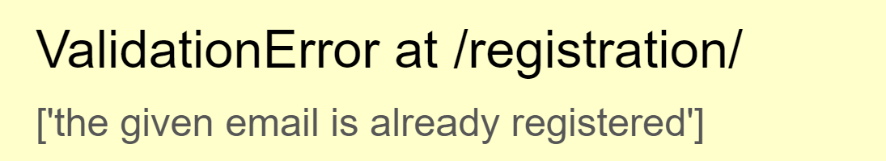

*Result*

The Iqueue prevents users to register with an already existing email

Overall results (Account Registration)

The registration component is robust with respect to many wrong input parameters from the users such as a birthday date which is in the future, a wrong email address or even worse an email address which is already used.

Author

Niccolò Veronese

# Test set: **Shop registration**

Software tested

**Iqueue – registration view**

Version

Latest

Goal

To show that the registration code is robust with respect to different inputs from the users.

* + 1. **Test Case 1: Birthday after the current date**

*Goal*

To show that the registration code will not allow to insert an invalid birthday

*Input*

Birthday: 0/7/2050

*Expected output*

“The birthday cannot be in the future”

*Actual output*

“The birthday cannot be in the future”

*Result*

The code is robust with respect to a user who tries to put a future birthday

* + 1. **Test Case 2: Wrong email**

*Goal*

To prove that the system will not allow to put an incorrect mail in the registration

*Input*

Email field: niccolo.veronese.it

*Expected output*

Impossible to create the account without a correct email field

*Actual output*



*Result*

The code shows good robustness with respect to wrong emails.

* + 1. **Case 3: Account with the same email address of another user**

*Goal*

To guarantee that two user do not have the same email address

*Input*

Email address: [gianluca99.giacomelli@gmail.com](mailto:gianluca99.giacomelli@gmail.com) (already existing)

*Expected output*

Validation error: "the given email is already registered"

*Actual output*



*Result*

The Iqueue prevents users to register with an already existing email

Overall results (Account Registration)

The registration component is robust with respect to many wrong input parameters from the users such as a birthday date which is in the future, a wrong email address or even worse an email address which is already used.

Author

Niccolò Veronese

* + 1. Software tested

**Iqueue – Shop view**

* + 1. Version

Latest

* + 1. Goal

To show that the registration shop code is robust with respect to different inputs from the users.

* 1. Test case
     1. **Case 1: opening time after the closing time**
        1. Goal

To show that the registration code will not allow to insert a invalid opening time

* + - 1. Input

Opening time 09:00 and Closing time 08:00

* + - 1. Expected output

“The opening time must be before the closing time”

* + - 1. Actual output

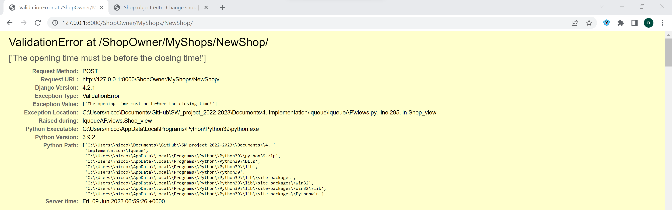

* + - 1. Result

The code is robust with respect to a user who tries to put a wrong opening/closing time

* + 1. **Case 2: Negative max number of clients**
       1. Goal

To prove that the system will not allow to put a negative max number of clients

* + - 1. Input

Max number = -2

* + - 1. Expected output

The code will not allow to enter a negative number

* + - 1. Actual output

The code do not write the minus symbol and it doesn’t allow to go below zero with the arrow of the button

* + - 1. Result

The code shows good robustness with respect to negative number of clients.

* + 1. **Case 3: Negative slot durations** 
       1. Goal

To guarantee that the shop owner must not enter a negative slot duration

* + - 1. Input

Negative slot duration

* + - 1. Expected output

The code does not write negative numbers

* + - 1. Actual output

The code does not write negative numbers in that field

* + - 1. Result

The Iqueue prevents users to register the shops with a negative slot duration

* 1. Overall results

The shop registration component is robust with respect to many wrong input parameters from the users such as a opening time which is after the closing time, negatives max numbers of clients and negatives time slots.

* 1. Author

Niccolò Veronese

1. **Test set: Booking and qr code reading** 
   1. Software tested

**Iqueue – Booking view, qr view**

* 1. Version

Latest

* 1. Goal

To show that the booking and the qr reading code is robust with respect to different inputs from the users.

* 1. Test case
     1. **Case 1: scan of an already used qr code**
        1. Goal

To show that the Iqueue app will not allow to scan two times the same qr code

* + - 1. Input

Qr code already used

* + - 1. Expected output

Impossible to scan the Qr code

* + - 1. Actual output

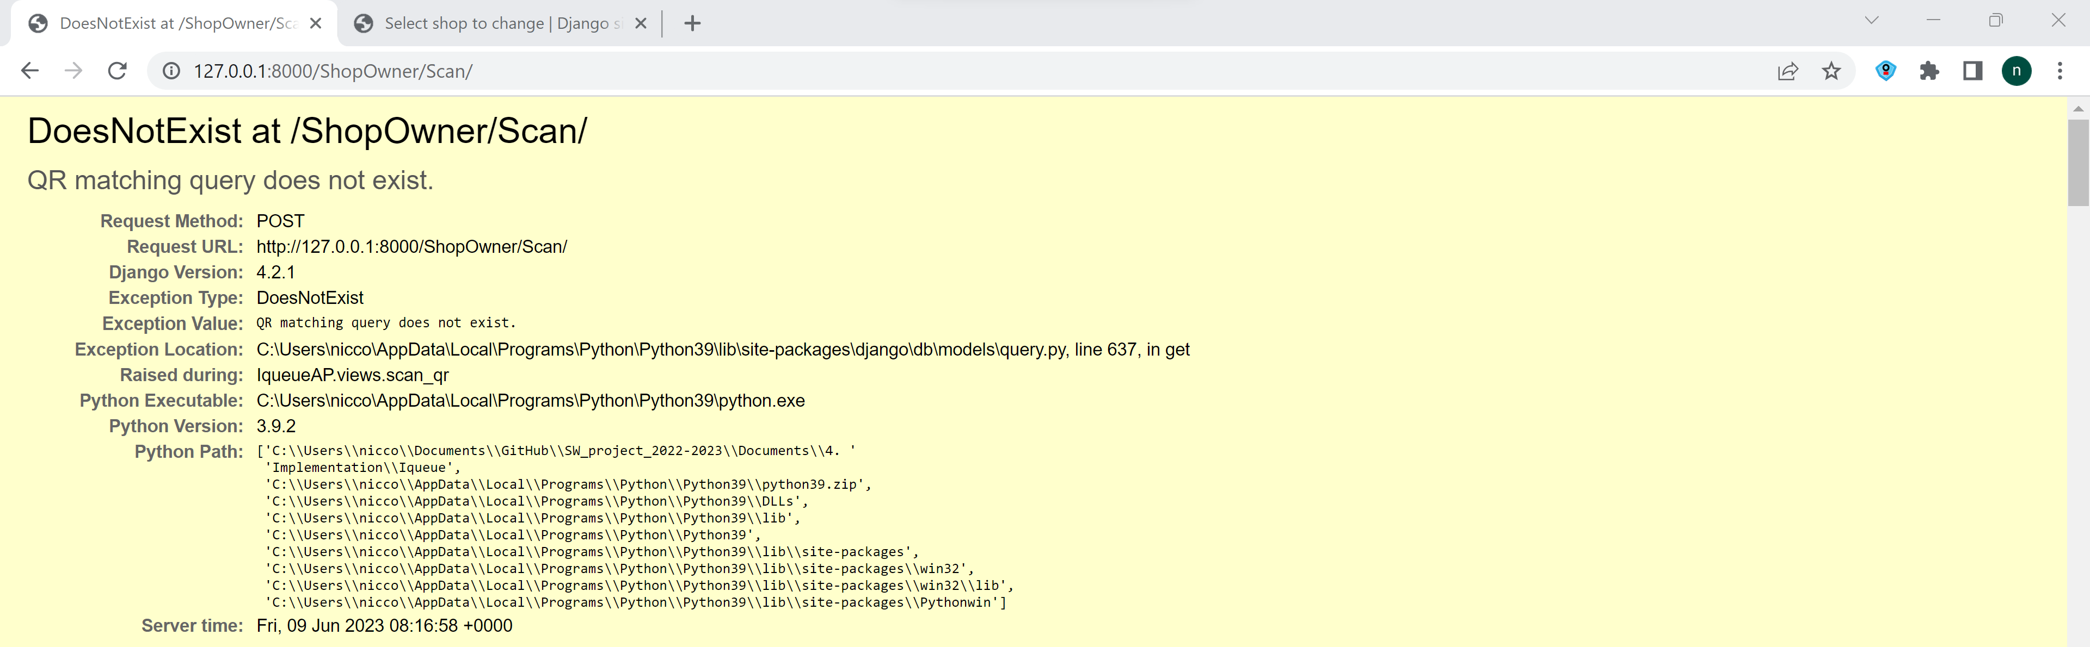

* + - 1. Result

The code will not allow to scan two times the same Qr code

* + 1. **Case 2: Selection of a time slot in the past**
       1. Goal

To prove that the system will not allow to book a passed time slot

* + - 1. Input

Time slot in the past: 31/05/2023

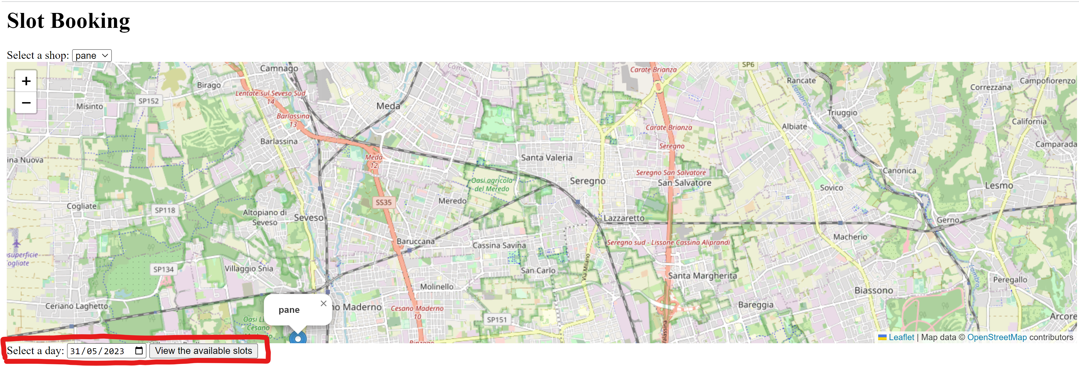

* + - 1. Expected output

The code will not allow to book a time slot in the past

* + - 1. Actual output

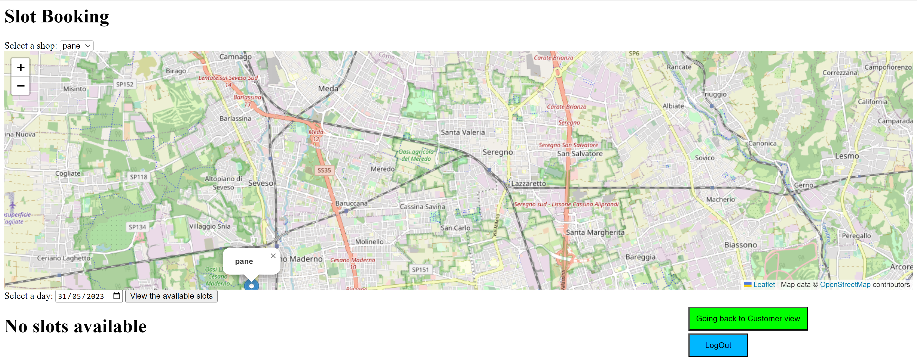

* + - 1. Result

The code shows good robustness with respect to slots in the past since it shows that no slots are available for that date.

* + 1. **Case 3: Slots too far in the future** 
       1. Goal

To guarantee that the customer cannot book a slot more than one year in advance

* + - 1. Input

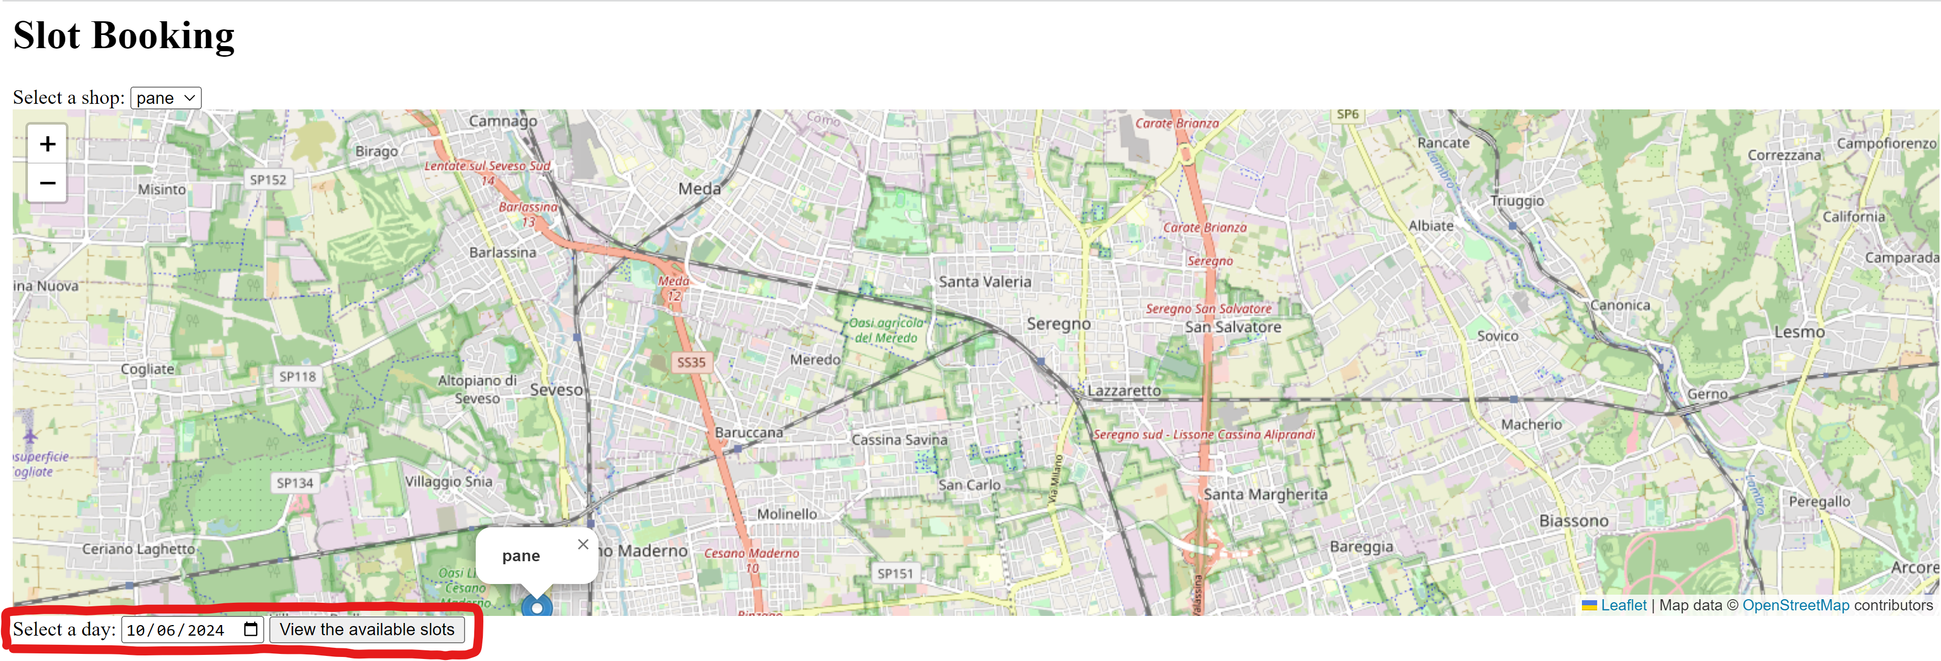

* + - 1. Expected output

The code will not show the available slots

* + - 1. Actual output

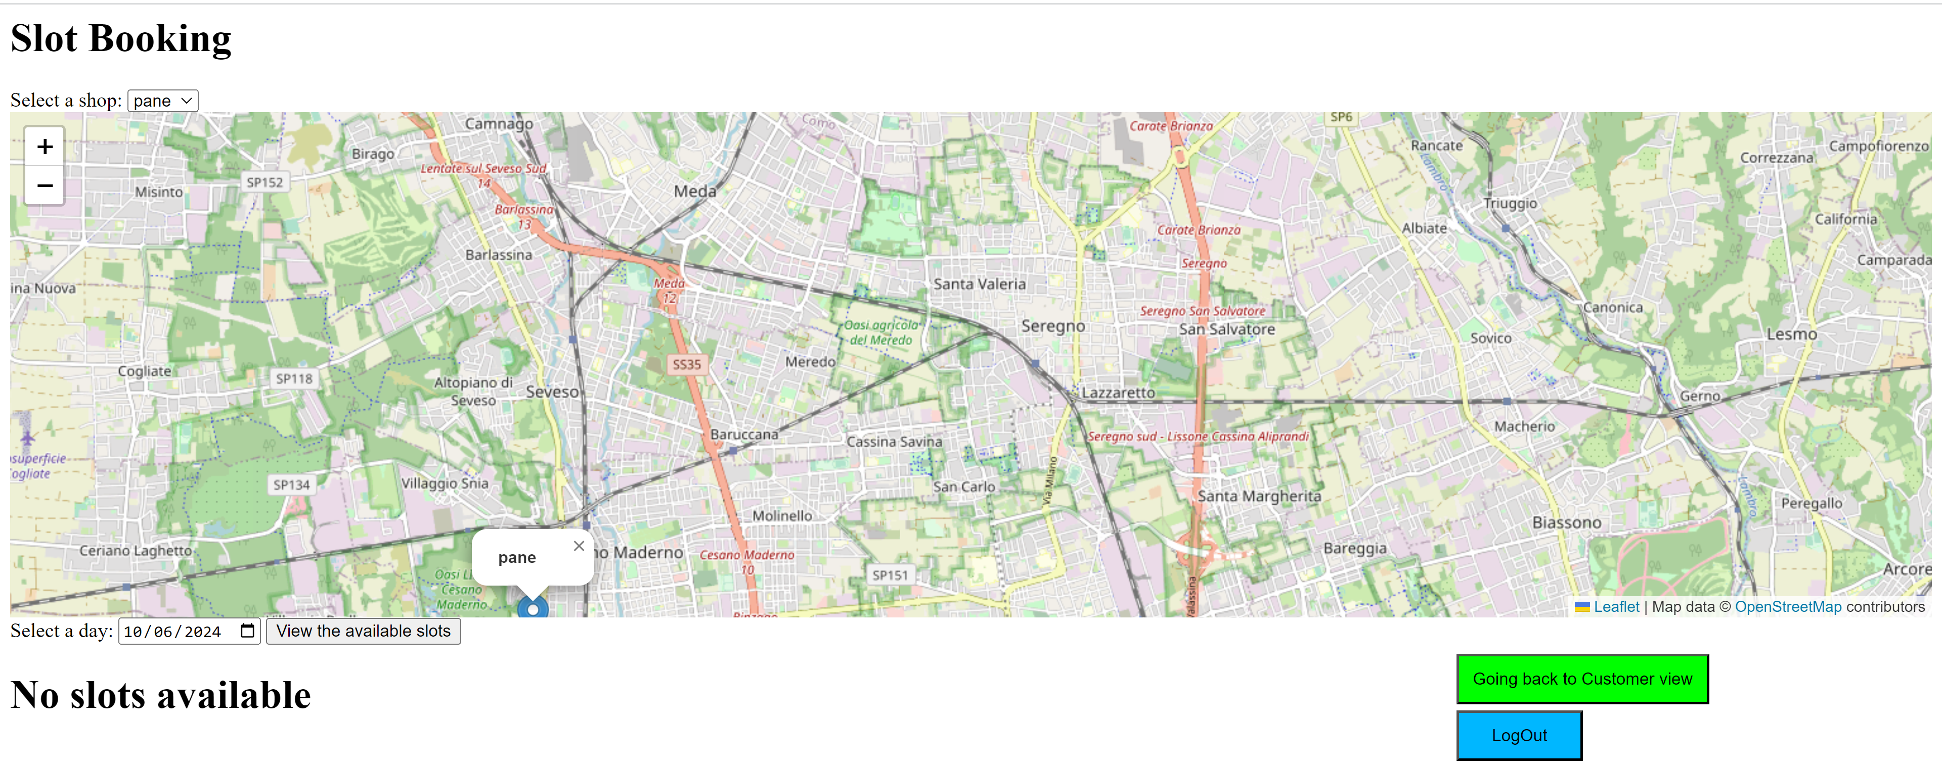

* + - 1. Result

The Iqueue prevents users to book a slot that is more than one year in advance

* 1. Overall results

The shop registration component is robust with respect to many wrong input parameters from the users such as a opening time which is after the closing time, negatives max numbers of clients and negatives time slots.

* 1. Author

Niccolò Veronese

1. **Test set: Queue (devo ancora finirlo)**
   1. Software tested

**Iqueue – Booking view, qr view**

* 1. Version

Latest

* 1. Goal

To show that the booking and the qr reading code is robust with respect to different inputs from the users.

* 1. Test case
     1. **Case 1: scan of an already used qr code**
        1. Goal

To show that the Iqueue app will not allow to scan two times the same qr code

* + - 1. Input

Qr code already used

* + - 1. Expected output

Impossible to scan the Qr code

* + - 1. Actual output



* + - 1. Result

The code will not allow to scan two times the same Qr code

* + 1. **Case 2: Selection of a time slot in the past**
       1. Goal

To prove that the system will not allow to book a passed time slot

* + - 1. Input

Time slot in the past: 31/05/2023



* + - 1. Expected output

The code will not allow to book a time slot in the past

* + - 1. Actual output



* + - 1. Result

The code shows good robustness with respect to slots in the past since it shows that no slots are available for that date.

* + 1. **Case 3: Slots too far in the future** 
       1. Goal

To guarantee that the customer cannot book a slot more than one year in advance

* + - 1. Input



* + - 1. Expected output

The code will not show the available slots

* + - 1. Actual output



* + - 1. Result

The Iqueue prevents users to book a slot that is more than one year in advance

* 1. Overall results

The shop registration component is robust with respect to many wrong input parameters from the users such as a opening time which is after the closing time, negatives max numbers of clients and negatives time slots.

* 1. Author

Niccolò Veronese

Test da fare:

white box per:

prenotazione

creazione advertisement

black box per:

qr reading

iscrizione account

iscrizione nuovi shop

iscrizione nuovi prodotti

lista persone in attesa